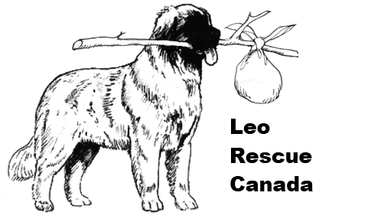 |  | Volunteer Form  Please send completed form to :  Leo Rescue Canada  Attention: Ms. Karen Heard  129 Brant School Road  Brantford, ON N3T 5L4  Email : Info@LeoRescueCanada.com

Thank you for your interest in volunteering and for wanting to make a difference in the lives of less fortunate Leonbergers. Being a non-profit rescue, we couldn’t do what we do without our compassionate and dedicated volunteers.

Please tell us about yourself:

Name:
Address:
Home Phone #: |  | Best time to reach you?
Business Phone #: |  | ( If you are able to be contacted at work )
Cell Phone #: |  | Email :

What is your availability? Please check all that apply
 |  | Weekdays during the day |  | Saturdays
 |  | Weekdays during the evening |  | Sundays

Do you have any experience with Leonbergers? Please explain.

Leo Rescue Canada - Volunteer Form continued |  | Page 2

What are you willing to do?

Reference checks for adoption / fostering
Home visits for adoption / fostering
Training (please list your experience)
Grooming / bathing dogs
Providing foster care (please complete the Foster Care Form)
Transporting a Leo to a foster and/or permanent home.
Do you own a large crate?
Identify a Leonberger in an animal shelter
Evaluate a Leonberger (Please list your experience)
Providing office services (i.e. photocopying, mailing, computer services, telephone work, etc.)
Fundraising
Other (please explain)

Do you have special skills and qualifications (i.e. are you a vet, groomer, breeder, etc.)?
Please explain:

Signature of Applicant |  |  | Date Signed

Thank you for offering your time and skills to Leo Rescue Canada. One of our representatives will be in touch soon.

Please see the first page for instructions regarding returning your signed form.

Leo Rescue Canada is a charitable organization registered under the Income Tax Act of Canada  Registration Number 81336 8685 RR0001 | Leo Rescue Canada  Form Revised:  March 2019

